JIM PREPARATORY NURSERY & PRIMARY SCHOOL
IKI-IKI
MOTTO: OUR GOD IS ABLE
TERM TWO ASSEAAMENT EXAMS SET V 2023
PRIMARY FOUR
SOCIAL STUDIES WITH RELIGIOUS EDUCATION
DURATION: 2HRS 15 MIN
NAME: ..................................................................................
STREAM: ..............................................................................

INSTRUCTIONS:
- This paper is made up of two sections A and B.
- Answer all questions carefully
- A good handwriting is expected.
- Unnecessary crossing may lead to loss of marks.
- Read the questions carefully before answering.

SECTION | EXAMINER’S MARK | HOD’S MARK
A
B
TOTAL

SECTION A (40 Marks)
1. Name the type of forest that provides hardwood.
......................................................................................................
2. Name one important place in our district which provides health
services.
......................................................................................................
3. Why are symbols and signs used on a map instead of real objects?
......................................................................................................
4. How is a farmer important to a community?
………………………...........................................................................
5. Name the physical feature that covers the largest part of Mukono district.

......................................................................................................
6. In which way is a radio important in our homes?
......................................................................................................
7. Mention one example of a political leader in a district.
......................................................................................................
8. What is a homestead?
......................................................................................................
9. How do factories benefit the people who live around them?
......................................................................................................
10. Name the map symbol below.

.....................................................

11. Write down one traditional method of preserving fish.
......................................................................................................
12. How are good roads important in an area?
…………………...............................................................................
13. Give any one danger of child abuse.

......................................................................................................
14. Mention one way of protecting lakes and rivers.
......................................................................................................
15. Which type of electricity is got from the sun?
......................................................................................................
16. Name the tool which is used to promote hygiene of the
classroom.
......................................................................................................
17. Why are school children advised to move in groups when going
home?
......................................................................................................
18. In which way are hills important in our communities?
......................................................................................................
19. Give one way the police enforce law and order.
......................................................................................................
20. Name the weather instrument which measures the depth of rain water into the soil.
......................................................................................................
21. Mention one economic activity which earns people money.
.......................................................................................................
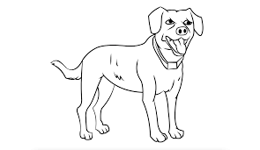

22.

How is the above animal important in a home?
.......................................................................................................
23. State one effect of too much sunshine.
.......................................................................................................
24. Which colour of the traffic lights tells the motorists to go?
.......................................................................................................
25. How is the work of a carpenter different from that of a builder?
.......................................................................................................
26. Give one source of food in our community.
……………………………………………………………………………………….
27. State any one danger a child without basic needs faces.
.......................................................................................................
28. Name one type of rainfall received in a given area.
.......................................................................................................
29. Why should a school have a playground?
.......................................................................................................
30. Which crop is grown for making clothes?
.......................................................................................................
31. How are swamps important to the craft industry?
.......................................................................................................
32. Write U.P.E in full.
.......................................................................................................
33. What is the main duty of the president in a country?
.......................................................................................................
34. Which type of weather is good for winnowing harvested cereals?
.......................................................................................................
35. Give any one material used for making local balls.
.......................................................................................................

For questions 36 – 40 , answer Either Christianity or Islam but not both on the same number.

36. Either:
Give one example of sin committed by Christians today.
........................................................................................................
Or:
Give one example of sin committed by Moslems today.
........................................................................................................

37. Either:
Name the holy book for Christians.
.......................................................................................................
Or:
Name the holy book for Moslems.
.......................................................................................................

38. Either:
Mention one benefit of fasting to a Christian.

.......................................................................................................
Or:
Mention one benefit of fasting to a moslem.
.......................................................................................................

39. Either:
How did Adam and Eve disobey God?
.......................................................................................................
Or:
How did Adam and Hawa disobey Allah?
.......................................................................................................

40. Either:
Give one miracle Jesus performed.
.......................................................................................................
Or:
Give one miracle Prophet Mohammed performed.

.......................................................................................................
SECTION B (60 Marks)
41. Study the diagrams below and answer questions that follow;
B
A
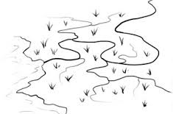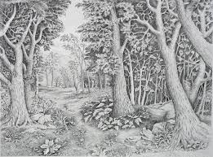

swamp forest
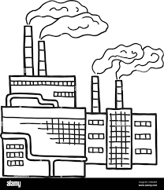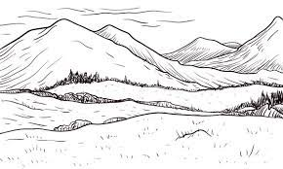
D
C
factory hills
(a) Mention any one raw material people get from feature marked
with A in diagram above.
…................................................................................................
(b) Give any one groups of people who depend on feature marked
with letter B in diagram above.
....................................................................................................
(c) Mention the feature where soil erosion may occur during rainy
seasons.
....................................................................................................
(d) State one danger caused by feature C in our environment.
……………………………………………………………………………………

42(a) How are leaders got at school?
....................................................................................................
(b) Write any two qualities of a good leader.
(i) ..............................................................................................
(ii) ..............................................................................................
(c) Give one type of leaders in our district.
....................................................................................................

43. Match correctly;

carpenter - grows crops
doctor - teaches learners
farmer - makes furniture
teacher - treats sick people

i) carpenter - ………………………………………………………………..
ii) doctor- …………………………………………………………………….
iii) farmer - …………………………………………………………………..
iv) teacher - …………………………………………………………………
44(a) In which region of Uganda is Mukono district located?
……..............................................................................................
(b) Write down any two regions in Uganda.
(i) .............................................................................................
(ii) ……………………………………………………………………………..
(c) Give a reason why districts are divided into sub-counties.
…………………………………………………………………………………

45. Study the diagram below and answer questions that follow.
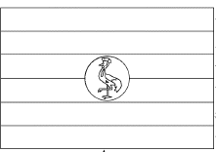

(a) How many stripes of colours does the flag above have?
…………………………………………………………………………………
(b) Which bird is shown on the above flag?
….………………………………………………………………………………
(c) For which country is the above drawn flag?
…..………………………………………………………………………………
(d) Give one place where the above flag can be flown.
…………………………………………………………………………………..

46. Use the picture below and answer the questions that follow.
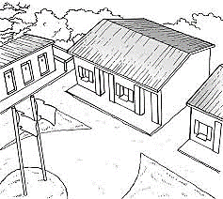
a) Mention the service provided at the above social service centre.
…................................................................................................

(b) Give two ways the community benefits from the social service
centre above.
(i) ..............................................................................................
(ii) ..............................................................................................
(c) Give one group of people who provide service at social service centre above.
……………………………………………………………………………………
47(a) Give two examples of children’s rights.
(i) ..............................................................................................
(ii) ..............................................................................................
(b) Write down two ways children’s rights are abused in society.

(i) ..............................................................................................
(ii) ..............................................................................................
48(a) Name any two activities done by people on the plateau.
(i) ..............................................................................................
(ii) ..............................................................................................
(b) Give the raw material obtained from the following lakes.
(i) lake Katwe
……………………………………………………………………………………
(ii) lake Albert
…………………………………………………………………………………….
49a) Name the road signs below.
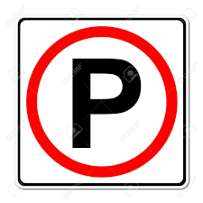
………………………………….. …………………………………….
(b) Write down two causes of road accidents.
i)…………………………………………………………………………………
ii)…………………………………………………………………………………

50a) What is a fishing ground?
…………………………………………………………………………………..
(b) How are good roads important for fishermen?
…….……………………………………………………………………………..
(c) State two importance of fish to people in our community.
i)………………………………………………………………………………..
ii)………………………………………………………………………………..

For questions 51 - 55, answer Either Christianity Or Islam BUT NOT BOTH.

51. Either:
(a) Name the place where Moses received the Ten Commandments.

……............................................................................................
(b) Write two commandments God gave to Moses.

(i) ...........................................................................................
(ii) ……………………………………………………………………………
(c) Why did God give Moses the Ten Commandments.
………………………………………………………………………………….
Or:
(a) Name the place where Prophet Mohammad received the Holy Quran.
……............................................................................................
(b) Write any three pillars of Islam.
(i) ............................................................................................
(ii) ............................................................................................
(iii) ……………..………………………………………………………………
52. Either:
(a) What name is given to the group of Christians worshipping God?
..................................................................................................
(b) State any two ways Christians worship God.
(i) ............................................................................................
(ii) ............................................................................................ (c) Give one reason why Christians worship God.
..................................................................................................
Or:
(a) What is Islam?
..................................................................................................
(b) Give two reasons why Moslems pray.
(i) ............................................................................................
(ii) ............................................................................................
(c) Write one way Moslems prepare for prayers.
..................................................................................................
53. Either:
(a) Give any two lessons we learn from the parable of the prodigal
son.
i)...............................................................................................
ii)………………………………………………………………………………
(b) State two ways children help others at school.
i)..............................................................................................
ii)……………………………………………………………………………..
Or:
(a) Give any two messages we learn from Prophet Mohammad.
i)...............................................................................................
ii)……………………………………………………………………………….
(b) State two ways children can help others at school.
(i) ...........................................................................................
(ii) ...........................................................................................

54. Either:
a) Name the first miracle Jesus performed.
………………………………………………………………………………….
b) Write two other miracles Jesus performed apart from the above.
i)………………………………………………………………………………..
ii)……………………………………………………………………………….
c) Give a reason why Jesus performed miracles.
………………………………………………………………………………….
Or:
a) Give two miracles Prophet Mohammad performed.
i)………………………………………………………………………………...
ii)………………………………………………………………………………..
b) Write two reasons why Prophet Mohammad performed miracles.
i)………………………………………………………………………………..
ii)……………………………………………………………………………….
55. Either:
(a) What should a good Christian do after sinning against God?
……..........................................................................................
(b) Mention two ways how people reconcile with each other.
(i) ............................................................................................
(ii) ............................................................................................
(c) Give a reason why forgiving those in wrong is good.
………………………………………………………………………………….
Or:
(a) What should a good Muslim do after sinning against God?
……...........................................................................................

(b) Mention two ways how people reconcile with each other.
(i) ............................................................................................
(ii) ............................................................................................
(c) Give a reason why forgiving those in wrong is good.
…………………………………………………………………………………
End

